2020 Leaving Cert Physics Solutions (Higher Level)

2020 Question1
- Draw a labelled diagram of the apparatus used in this experiment.
runway //air track
two trolleys // two gliders/riders

- How did the student measure the masses of the trolleys?
used electronic balance / mass balance

- Describe how the distance was measured.
metre stick/ measuring tape
- Describe how the time was measured.
tickertape / timer // photogates / timer
time between dots is 0.02 s // difference between entry/exit times
- How did the student use the distance and the time to calculate the velocity?
velocity = distance divided by time

- What is the momentum of trolley B before the collision?
0 kg m s^{‐1}
- Calculate the combined momentum of trolleys A and B after the collision (Show your work.)
(0.38 + 0.35)(0.78) = 0.569 kg m s^{‐1}

- Was momentum conserved in this collision? Explain your answer.
yes
momentum before was the same as momentum after

2020 Question 2
- Draw a labelled diagram of the apparatus used in this experiment.
concave mirror
object e.g. crosswire
image / screen
correct arrangement
detail e.g. optical bench, metre stick, ray‐box, etc.
- State the formula used to calculate the focal length.
$$\frac{1}{f}=\frac{1}{u}+\frac{1}{v}$$
- On your diagram, indicate and label the measurements taken by the student.
correctly marked u and v distances
- What instrument was used to take these measurements?
metre stick/ measuring tape
- Why did the student measure the approximate focal length at the start of the experiment?
to ensure the object is placed outside the focal point // so that a real image could be formed
- The image distance is the less accurate measurement. Explain why.
difficult to decide location of sharpest image

2020 Question 3

- Draw a labelled diagram of the apparatus used in this experiment.
labelled diagram to show:
string
means of changing frequency e.g. tuning forks / frequency generator
means of varying length e.g. bridge
means of measuring length
means of detecting resonance /paper rider /magnet
detail e.g. sonometer, means of tightening
- On your diagram, indicate and label the length measured by the student.
distance between the bridges shown on the diagram

The student completed the following graph to show the relationship between length and frequency.
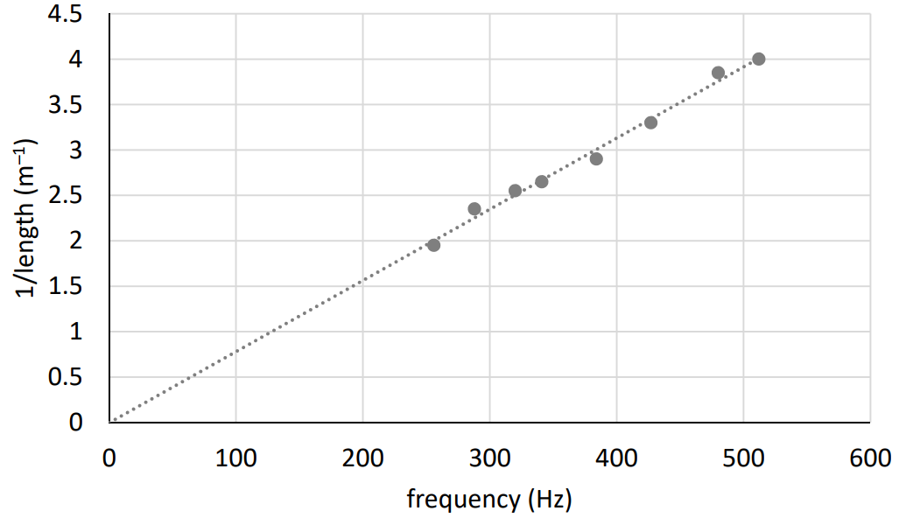

- How did the student measure the frequency values?
noted it from tuning forks // read it from signal generator
- How did the student set the string vibrating?
placed a vibrating tuning fork on bridge // varied the frequency of the signal generator

- Describe how the student knew that resonance had occurred.
paper rider falls off // loudest sound
- State the relationship between the resonance frequency and the length.
frequency is inversely proportional to the length

2020 Question 4
- Name the instrument used to measure resistance.
ohmmeter
- Name the instrument used to measure temperature.
thermometer / temperature probe
- How did the student change the temperature of the metallic conductor?
placed in liquid and placed the container over a source of heat
- Use the data to plot a graph to show the relationship between resistance and temperature.
label axes correctly, (name / symbol / unit acceptable)
plot six points correctly
straight line
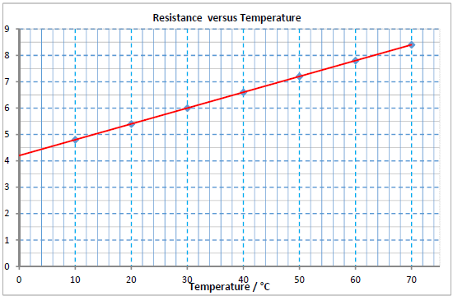
- Describe the relationship between resistance and temperature.
resistance increases with temperature and it is a linear relationship
- State one safety precaution that the student should have taken.
use a tongs / tie back hair / wear goggles

2020 Question 5
Answer any eight of the following parts (a), (b), (c), etc.
- Explain Archimedes’ principle. The diagram may help you answer.
When an object is immersed in a fluid the upthrust (apparent loss in weight) it experiences = weight of displaced fluid
- What is meant by latent heat?
heat/energy needed to change state
- Which of the following is the SI unit of capacitance?
farad
- State Boyle’s law.
pressure and volume are inversely proportional for a fixed mass of gas
- Which fuse should be used in the plug, a 3 A fuse or a 13 A fuse?
P = VI I = P/V I = 1500/230 = 6.5 A so the current would blow the 3 A fuse.

- What is a magnetic field?
region/space where magnetic forces can be experienced
- State two properties of ultraviolet light.
travels at c, high energy/frequency, causes ionisation, etc.
- A pair of complementary colours consists of a primary colour and a secondary colour that mix to give white light. Name a pair of complementary colours.
blue and yellow // red and turquoise/cyan // green and magenta
- Name the piece of equipment on the right.
spectrometer
- What is nuclear fusion?
joining of two nuclei with the release of energy

2020 Question 6

- Use Newton’s first law of motion to find the force that the crane puts on the block.
If it’s going at constant velocity then the net force acting on it must be zero so
crane force up = weight of block down = 400 N

- Calculate the resultant (net) force on the 9 kg object in the diagram above.
2 N
- In what direction does it act?
to the right
- Calculate the acceleration of the 9 kg object.
F = ma a = F/m = 2/9 = 0.22 m s⁻²

- State Newton’s third law of motion.
If object A exerts a force on object B, B exerts an equal and opposite force on A.
- Use Newton’s third law to explain how a rocket takes off.
when the rocket forces gas down, the gas applies a force up on the rocket

- Calculate the kinetic energy of the car when it is travelling at 18 m s^{–1}.
E = ½mv² = ½(700)(18)² = 113400 J
- Calculate the acceleration of the car.
$a=\frac{v-u}{t}=\frac{18-0}{6}$ = 3 m s⁻²
- Calculate the net force on the car as it accelerates.
F = ma = (700)(3) = 2100 N

- Calculate the friction acting on the car.
3000 – 2100 = 900 N
- State one method of reducing friction.
oil moving parts etc.

- Question 7

- State Snell’s law of refraction.
sine of the angle of incidence is proportional to sine of the angle of refraction // sin i ∝ sin r
- Describe an experiment to demonstrate Snell’s law.
apparatus: glass/plastic block
ray box / laser / optical pins / protractor
procedure: draw refracted rays and measure values for i and r
observation /conclusion: Sin i ∝ sin r
- Use Snell’s law to calculate the refractive index of water.
$n=\frac{\sin{36}}{\sin{26}}$ = 1.34
- What does C stand for in the formula written above?
critical angle

- Copy and complete the diagram below to show the paths of the rays of light after they strike the converging lens.
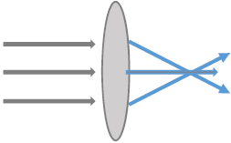

- Explain the underlined term.
A virtual image is formed by the apparent intersection of rays
- Calculate the image distance, v.
$\frac{1}{f}=\frac{1}{u}+\frac{1}{v}$ $\frac{1}{v}=\frac{1}{f}-\frac{1}{u}$ $\frac{1}{v}=\frac{1}{15}-\frac{1}{20}$ $\frac{1}{v}=\frac{1}{60}$ v = 60 cm
- Calculate the magnification, m.
$m=\frac{v}{u}=\frac{60}{20}$ magnification = 3

- State one use of a lens.
magnifying glass, eye glasses /spectacles, camera, telescope etc

2020 Question 8

- Name the parts of the gold leaf electroscope labelled A, B and C.
A = (metal) cap / disc
B = insulation
C = (gold) leaf
- Describe how a student would charge a plastic rod.
rub with a (dry) cloth / fur

- How would the student use a gold leaf electroscope to show that the rod is charged?
bring the charged rod close to the cap // touch the cap with the charged rod
leaf moves

- State the SI unit of electric charge.
coulomb

- Explain how this happens.
charged rod induces opposite charge on the paper
opposite charges attract

- Describe, with the aid of a labelled diagram, an experiment to show an electric field pattern.
dish of (castor) oil
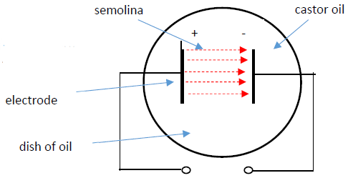
high voltage source
two electrodes/plates
semolina forms electric field pattern
field lines go from positive to negative
- State another example of an inverse square law.
Newton’s law of universal gravitation

2020 Question 9

- Light is an example of a transverse wave. Explain what is meant by a transverse wave.
disturbance is perpendicular to direction of propagation of the wave
- Calculate the wavelength of the orange light.
$c=fλ$ $λ=\frac{c}{f}$ $λ=\frac{3 ×{10}^{8}}{5 × {10}^{14}}$ $λ$ = 6 × 10⁻⁷ m
- Describe an experiment to show that sound needs a medium to travel through.
apparatus: bell jar with electric bell, battery, vacuum pump
procedure: turn on pump
observation/conclusion: no sound heard when air removed / sound needs a medium
- What is meant by reflection?
waves rebounding /bouncing off a surface
- Describe an experiment to show the interference of sound waves.
apparatus: tuning fork
procedure: strike the tuning fork and rotate it close to your ear
observation/ conclusion: the emitted sound increases and decreases in loudness due to interference
- Sound waves do not undergo polarisation. Explain why.
longitudinal // not transverse

- Describe a laboratory experiment to demonstrate the Doppler effect.
apparatus: buzzer/sound source
procedure: turn on sound source and rotate using string
observation/conclusion: frequency /pitch changes (as sound source moves closer/away)

- State one use of the Doppler effect.
measuring speed / speed gun, (measuring) red shift, ultrasonic scanners, imaging
used to study blood flow, used to study heartbeat, weather forecasting, etc.

2020 Question 10

- Where in the atom is the electron found?
(obits) outside the nucleus
- Compare the mass of an electron to the mass of a proton.
electron has smaller mass // 9.1×10^{‐31} versus 1.67×10^{‐27}
- What is meant by thermionic emission?
release of electrons from the surface of a hot metal
- Draw a labelled diagram of a cathode ray tube.
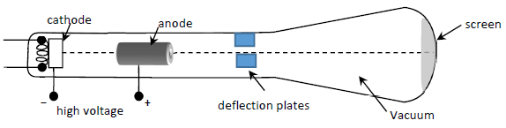
- How are the electrons detected in a cathode ray tube?
flashes of light / scintillations (on fluorescent screen)
- State one use of a cathode ray tube.
CRO, old TV monitors, ECG screens, etc.
- Describe an experiment to demonstrate the photoelectric effect.
apparatus: (gold leaf) electroscope , UV lamp
procedure: place a zinc plate on the cap of the electroscope / charge the electroscope
negatively / shine the UV lamp on the zinc plate
observation /conclusion: the leaf collapses /electrons emitted
- The picture shows an X‐ray tube. What is an X‐ray?
high energy/frequency electromagnetic radiation
- Explain why the production of X‐rays can be considered to be the opposite of the photoelectric effect.
production of X‐rays: fast electrons produce X‐radiation
photoelectric effect: high frequency radiation produces electrons
- State one danger associated with X‐rays.
can cause skin burns, cancer, ionise cells, death, etc.

2020 Question 11
- Name two greenhouse gases that are contributing to climate change.
carbon dioxide/CO2, methane / CH4, nitrous oxide/N2O
- State one of the impacts of climate change that Ireland has experienced.
flooding, drought, heavy snow
- What energy conversion takes place when this happens?
chemical to kinetic // chemical to electric // electric to kinetic
- What is renewable power?
power from a source that does not get depleted
- What is the SI unit of power?
watt
- What is meant by U‐value?
energy passing through a material per m² per K per s
- Calculate the power of the turbine.
$P=\frac{W}{t}=\frac{90×{10}^{6}}{60}$ = 1.5 × 10⁶ W
- Other than wind energy, name two other sources of renewable power used in Irish homes.
solar, wave, tidal, hydro, geothermal, biomass

2020 Question 12 (a)

- Convert 30 km into metres.
30000 m
- Convert 28 minutes into seconds.
28 × 60 = 1680 s
- Use your answers to (i) and (ii) to calculate the speed of the bus in m s^{–1}.
$v=\frac{s}{t}=\frac{30000}{1680}$ = 17.86 m s⁻¹
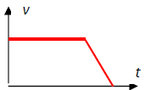
- Sketch a velocity‐time graph of the bus’s journey.
See diagram, although it should have the velocity of 17.86 noted on the velocity axis.
- What is the difference between speed and velocity?
velocity is the speed in a given direction

2020 Question 12 (b)
- What is meant by temperature?
degree of hotness // measure of how hot or cold a body is.
- Body temperature is 37 °C. Convert this to kelvin (K).
37 + 273 = 310 K

- What is a thermometric property?
one that changes measurably with changing temperature
- Name one example of a thermometric property.
colour, resistance, pressure, volume, emf, voltage, etc.
- Describe an experiment to calibrate a thermometer.
apparatus: beaker of water, heat source, calibrated and uncalibrated thermometers 3
procedure: measure thermometric property at different reference temperatures 3
observation/conclusion: draw a scale/ graph

2020 Question 12 (c)

- Name a material that is an electrical conductor.
metal
- What is the name given to a material that does not allow electric charge to flow through it?
insulator
- Describe an experiment to show that a material is an electrical conductor.
apparatus: circuit to show power source, ammeter/ bulb, leads, contacts
procedure: connect the circuit and place item between contacts
observation/conclusion: bulb lights / item conductor
- Calculate the total resistance in the circuit shown above.
6 + 8 = 14 Ω
- Calculate the current flowing in the circuit.
I = V/R = 12/14 = 0.86 A

2020 Question 12 (d)
- Which type of radiation is the most penetrating?
Gamma
- Describe an experiment to compare the penetrating power of alpha, beta and gamma radiation.
apparatus: radioactive sources, barriers, detector/GM tube any two
procedure: place different barriers between the sources and the detector
observation/conclusion: alpha is stopped first // gamma penetrates best

- Calculate the atomic number, A, of the unknown element X.
84
- Calculate the mass number, Z.
216
- Name element X.
Polonium / Po
- State one use of nuclear radiation.
sterilise food, sterilise medical equipment, cancer therapy, energy source, etc

